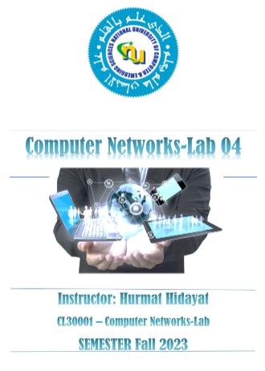

Name :Muhammad Shaheer

Roll no: 20p-0480

Lab task: 6

NATIONAL UNIVERSTIY OF COMPUTER AND EMERGING SCIENCES, FAST- PESHAWAR CAMPUS

**Design, label and Configure the following topology in cisco packet tracer**

**Make topology like this:**

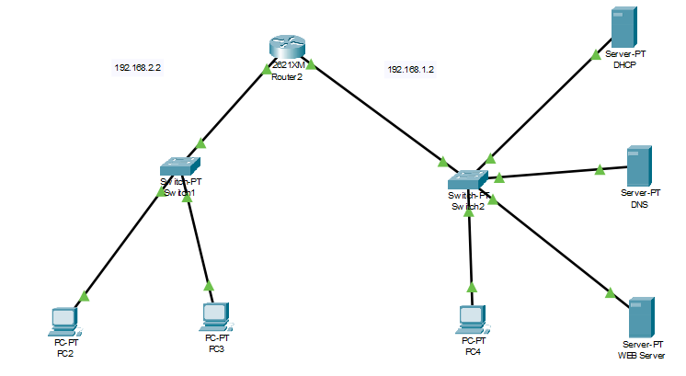

For Router configuration:

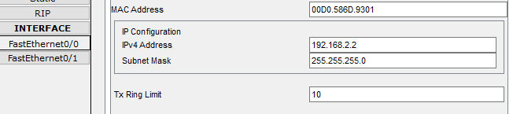

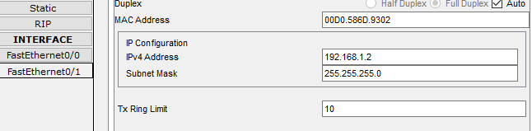

FOR DHCP SERVER CONFIGUARATION:

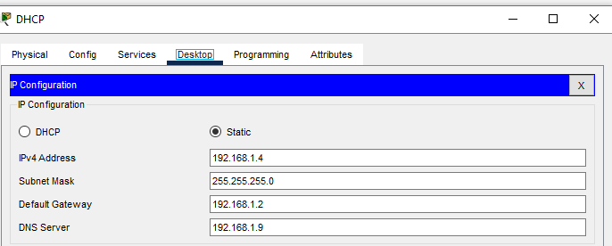

For DHCP Services:

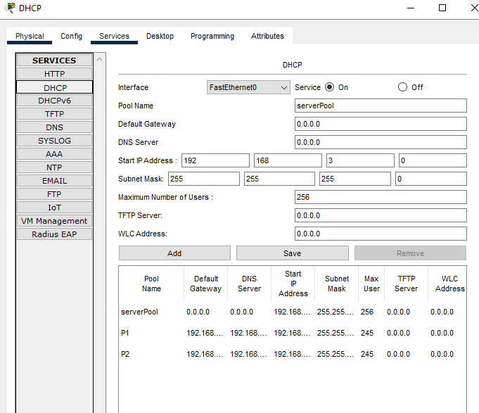

For DNS Server configuration:

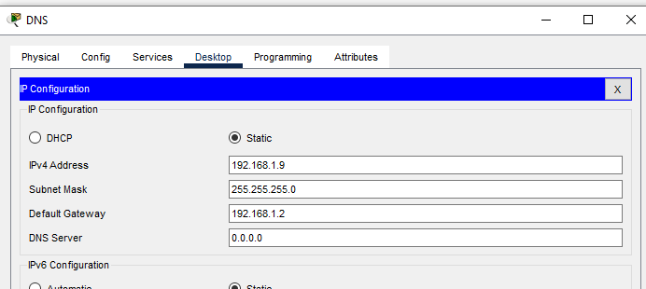

For DNS Services:

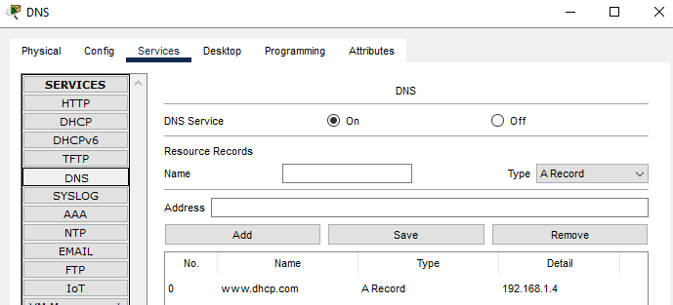

FOR Web server configuaration:

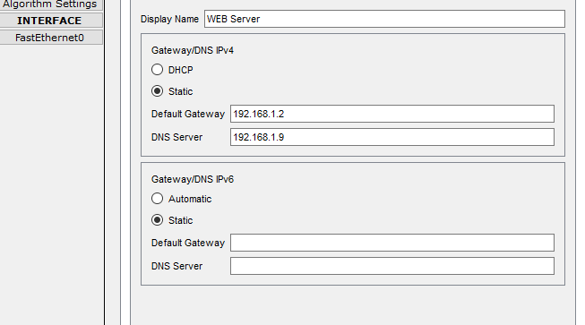

For web services:

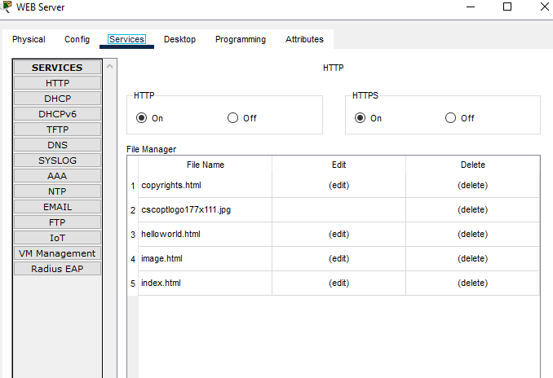

Change HTML file:

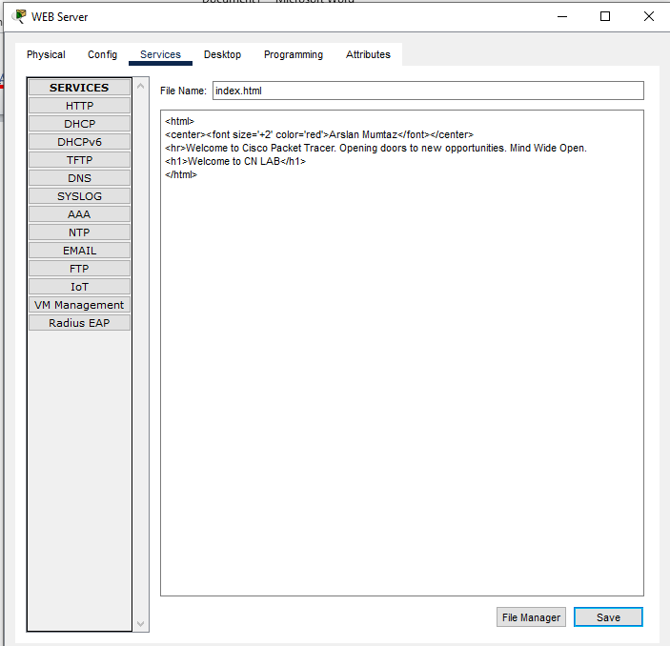

Now For PC 4:

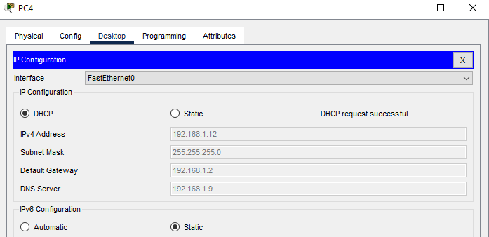

USE HELPER ID FOR other network pcs

For PC 2:

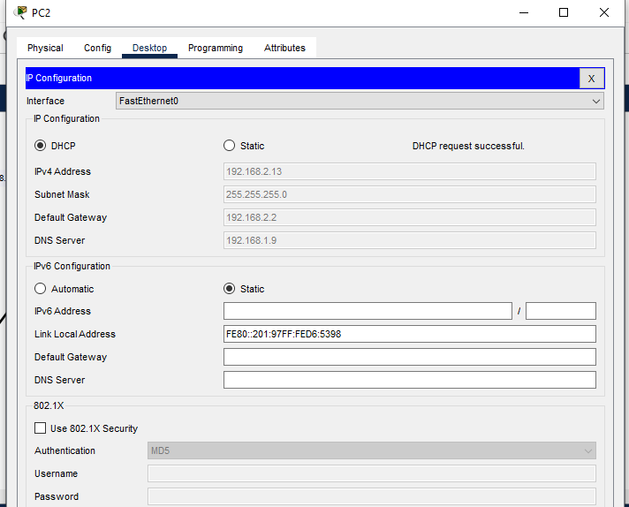

For PC 3:

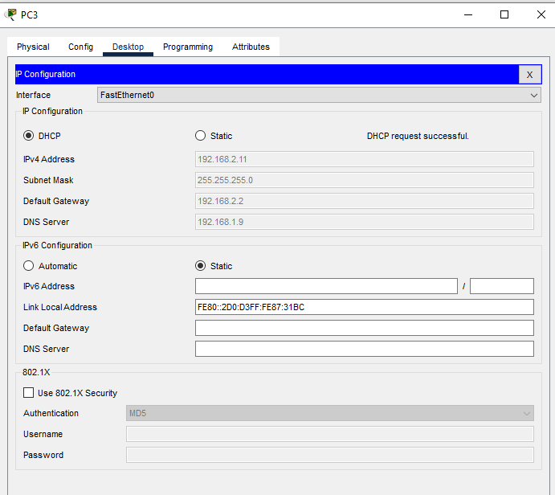

Now check for ping request and message transformation:

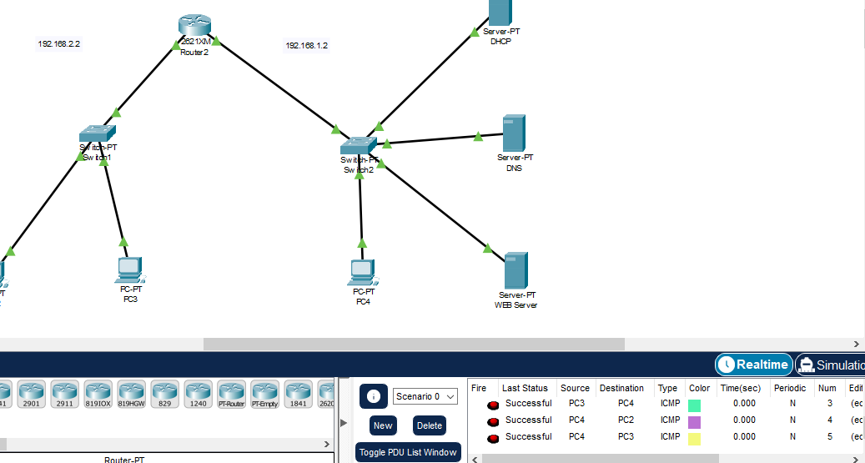

Hence our network is stable.